SIMATS ENGINEERING
ASSESSMENT TOOL 2
COURSE NAME: CRYPTOGRAPHY AND NETWORK SECURITY COURSE CODE: CSA5115
COURSE OUTCOME COVERED
CO2: Analyze Public Key crypto system strategies using RSA and key Exchange for Encryption algorithm to strengthen information security. (BL4,BL5)
Scenario-Based : 20%
QUESTIONS: Total Marks: 50 Annexure A
Code of Conduct:
I S.Adhikesavan - 192521172(Name / Reg No) certify that this submission is my original work and that I have adhered to the guidelines specified for this assessment. I understand that any violation of academic integrity rules will result in disciplinary action.

Signature of the student: Adhikesavan

Annexure A

Scenario-based

4. Public Key Cryptography for Email Security
An organization plans to implement RSA for secure email communication.
A. Describe how RSA can be used for encryption and decryption in this scenario.
B. Explain how key distribution and management play a role in maintaining security.

5. Cryptography for IoT Devices
A smart home system uses low-power IoT devices that need secure communication. The designer must choose between RSA and Elliptic Curve Cryptography (ECC).

Solution :

4. Public Key Cryptography for Email Security

- How RSA is Used for Encryption and Decryption

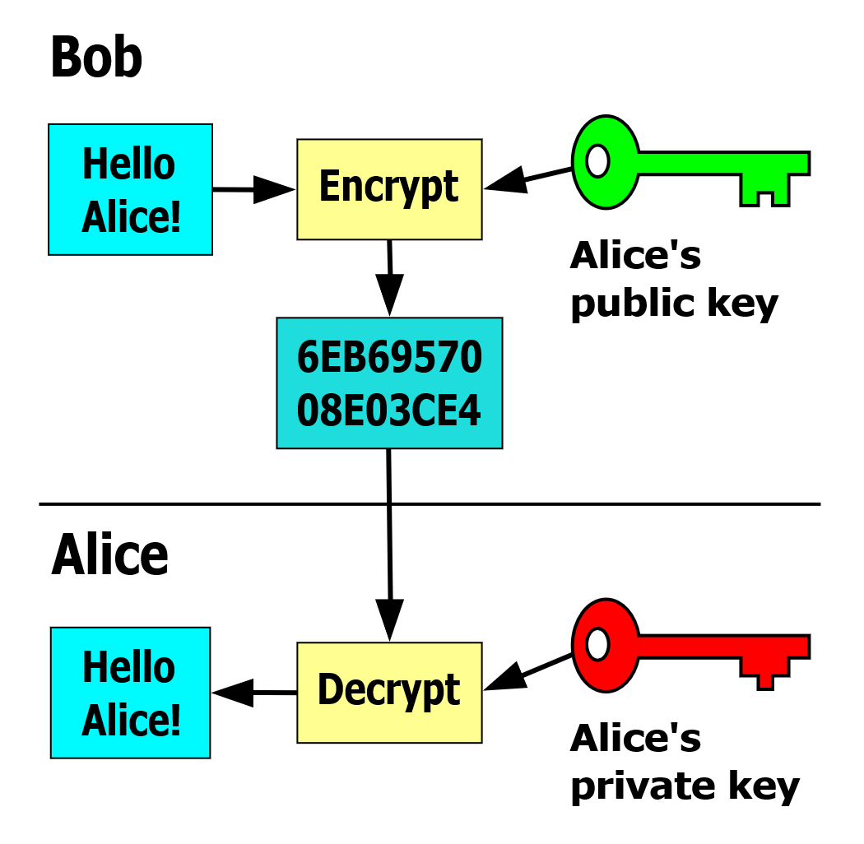

RSA is a public key cryptography algorithm that helps protect email communication. It uses two keys: a public key, which is shared with others, and a private key, which is kept secret by the owner.

When a person wants to send a secure email, they encrypt the message using the recipient's public key. Once the email is encrypted, only the recipient's private key can decrypt it and reveal the original message. This ensures that even if someone intercepts the email, they cannot read its contents without the private key.

For example, if Alice wants to send confidential information to Bob, she encrypts the email using Bob's public key. Bob then uses his private key to decrypt and read the message. RSA can also create digital signatures, allowing the recipient to verify that the email was sent by the correct person and that it has not been modified.

- Role of Key Distribution and Management

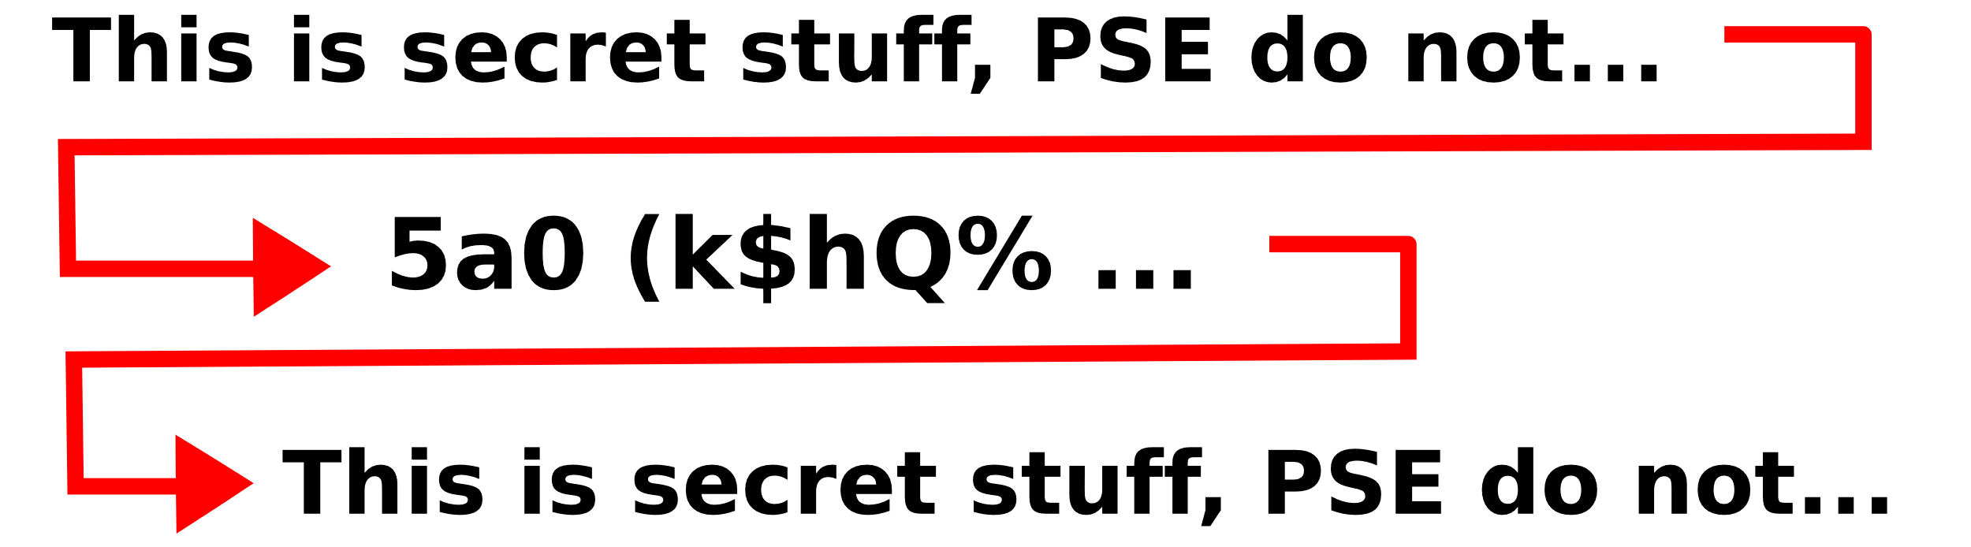

Key distribution and management are important for keeping RSA secure. Public keys should be shared through trusted methods, such as digital certificates issued by a Certificate Authority (CA), to ensure they belong to the correct user. If an attacker replaces a public key with a fake one, sensitive information could be exposed.

Private keys must always remain confidential and should be stored securely. Organizations should also have procedures for updating, backing up, and revoking keys if they are lost or compromised. Proper key management protects the confidentiality, authenticity, and integrity of email communication.

5. Cryptography for IoT Devices

- Constraints of IoT Devices

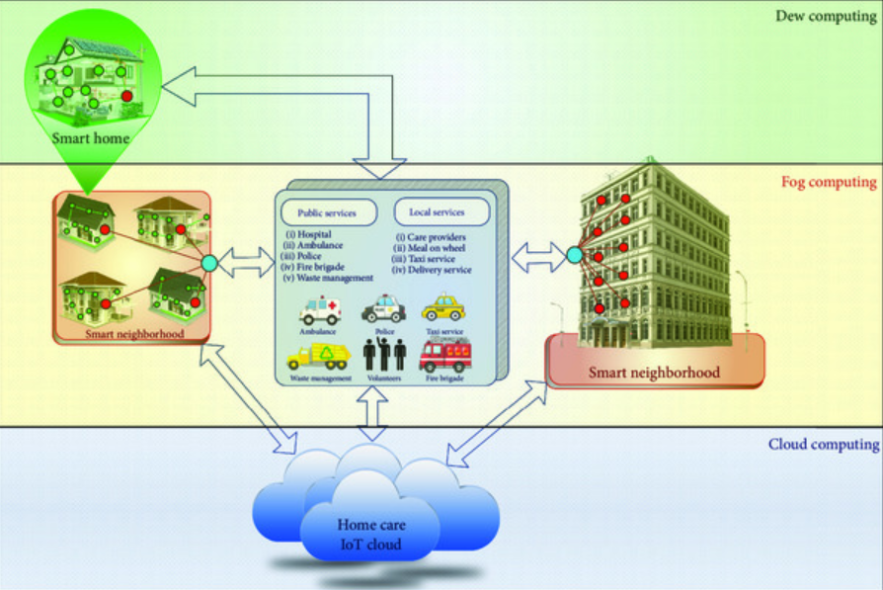

IoT devices, such as smart sensors, smart lights, and home security systems, have limited hardware resources.
They usually have low processing power, limited memory, small storage capacity, and operate on batteries.
Because of these limitations, they cannot efficiently run cryptographic algorithms that require high computational power. At the same time, these devices must protect sensitive information from cyber threats, making efficient security essential.

- Recommended Cryptographic Approach

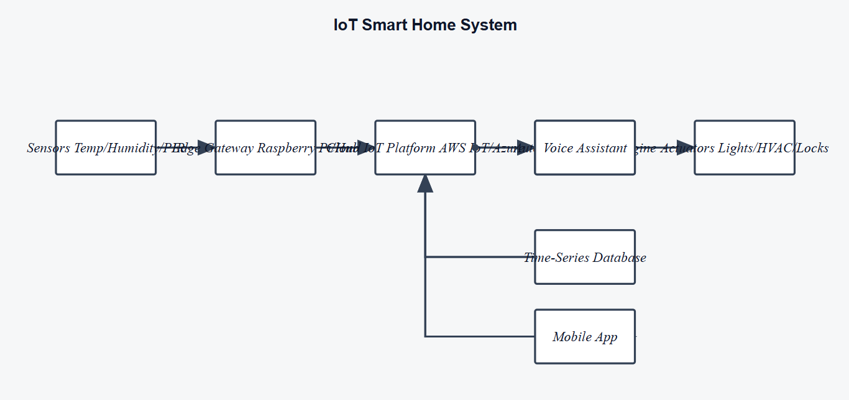

For IoT devices, Elliptic Curve Cryptography (ECC) is the better choice compared to RSA. ECC provides the same level of security as RSA but uses much smaller key sizes. For example, a 256-bit ECC key offers security comparable to a 3072-bit RSA key.

Smaller keys mean faster encryption and decryption, lower memory usage, reduced power consumption, and less bandwidth usage. These advantages make ECC well suited for battery-powered and resource-constrained IoT devices.
Although RSA is reliable and widely used, its larger key sizes require more processing power and memory, making it less efficient for smart home environments.

ECC is the most suitable cryptographic solution for IoT devices because it provides strong security while minimizing the use of computing resources and energy. This makes it ideal for secure and efficient communication in modern smart home systems.

Criteria | Weighta  ge (%) | Level 4  (Exemplary ) | Level 3  (Proficient) | Level 2  (Developing ) | Level 1  (Beginnin g)
Understandi ng of  Scenario | 20% | Demonstrat es clear and complete  understandi ng of the  scenario  and context | Shows good understandi ng with  minor gaps | Partial  understandi ng; misses  key aspects | Misinterpre ts or fails  to  understand the  scenario
Identification of Key  Issues | 20% | Accurately identifies all relevant  issues and factors  involved | Identifies  most key  issues with minor  omissions | Identifies  limited  issues;  some  irrelevant  points | Unable to  identify key issues
Application of Concepts | 25% | Applies  appropriate concepts  effectively  to address the scenario | Applies  concepts  with minor  errors | Limited or  partially  correct  application | Unable to  apply  relevant  concepts
Decision  Making | 20% | Makes well reasoned,  logical  decisions  with strong rationale | Makes  reasonable decisions  with some  justification | Makes weak decisions  with limited justification | No clear  decisions  made or  rationale  provided
Clarity of  Response | 15% | Response is clear,  structured, and logically presented | Generally  clear with  minor  issues | Somewhat  unclear or  poorly  structured | Disorganiz ed and  difficult to  understand

